Pedelec deregulation

# Objective

The objective was to deregulate a commercially available pedelec. This report describes the design of the prototype deregulator, project success criteria and performance against them, but first a watch out.

# UK/EU eBike Regulations

In the EU and UK use of deregulated pedelecs on public roads, cycle paths and bridleways is illegal without registration with the DVLA. From Cycling Weekly:

The UK legislation was harmonised with EU law EN15194 in April 2015, which means that it could change as Brexit takes effect. But for now it’s pretty clear in defining what can – and what cannot – be called an ebike.

Your steed is an “electrically assisted pedal cycle” (or EAPC, or ebike, or Pedelec) if: the bike has pedals that propel it; the electric motor won’t assist you when you’re travelling more than 25 km/h (15.5mph); and the power doesn’t exceed 250 watts.

The cycles that meet these requirements (which affect two-wheeled bikes but also tandems and tricycles) can be ridden on any cycle paths and anywhere else that bikes are normally allowed …

**If your ebike doesn’t meet these regulations – either because the motor is more powerful than 250W, or if it assists you when you’re riding more than 15.5 mph – it will need to be registered, insured and taxed as a motor vehicle. In this case, you will also need a driving licence, and you must wear a motorcycle helmet.**

These other kind of bikes (also called speed pedelecs) cannot be ridden on cycle paths and must be approved by the DVLA. So while it’s easy to de-restrict an ebike to get the motor assisting you with higher speeds, it is not very wise to do so, both for regulatory and safety reasons.

Read more at [https://www.cyclingweekly.com/news/product-news/electric-bikes-uk-law-234973](The%20UK%20legislation%20was%20harmonised%20with%20EU%20law%20EN15194%20in%20April%202015,%20which%20means%20that%20it%20could%20change%20as%20Brexit%20takes%20effect.%20But%20for%20now%20it’s%20pretty%20clear%20in%20defining%20what%20can%20–%20and%20what%20cannot%20–%20be%20called%20an%20ebike.%20%20Your%20steed%20is%20an%20)

# The pedelec – Kalkhoff Agattu

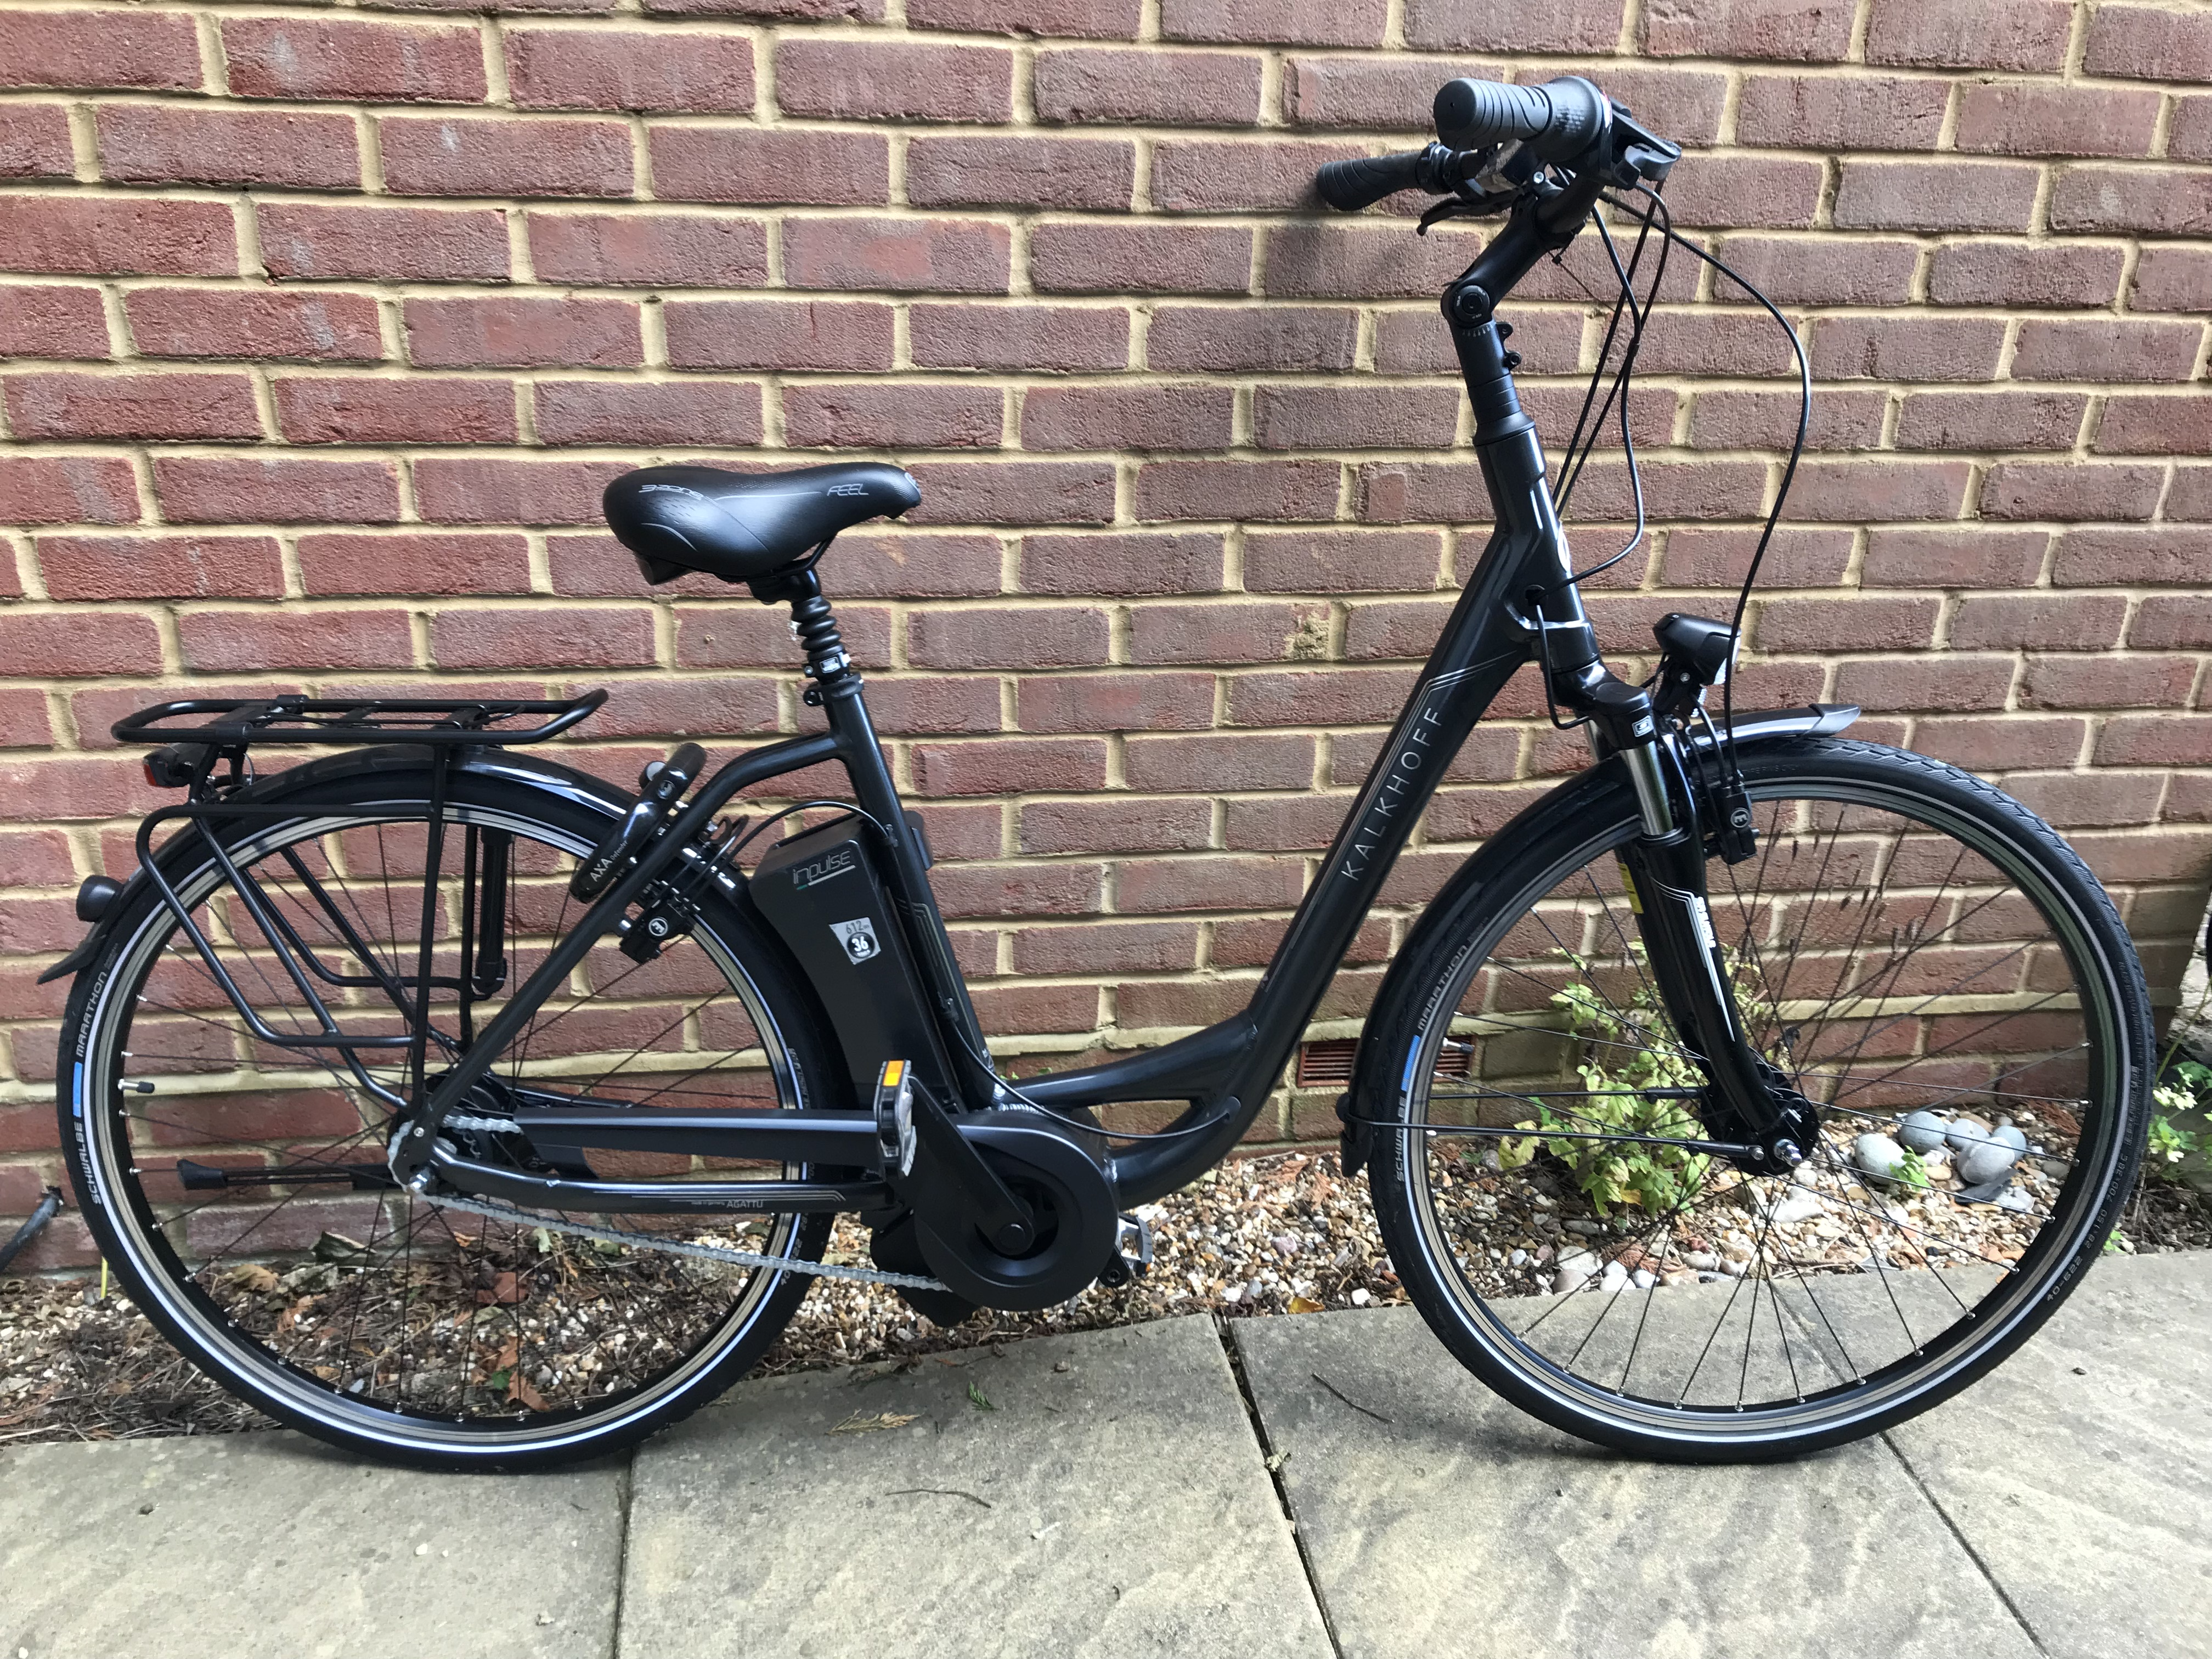

Motor power 250W  
Battery capacity 612Wh  
Weight 27kg  
Wheel diameter 700mm nominal (700C)

# Success criteria

* No change to bike equipment, e.g. substituting the reed switch for another type of switch
* Cost of components < £10
* Lifetime of deregulator battery > 1year
* Compact, lightweight – accommodate safely on rear stay. The mounting must conform to the curved section of the stay
* Need to provide immediate motor power after a period of standstill, e.g. after wait at traffic lights

# Principle of design

A reed switch activated by a magnet on a wheel spoke provides input to the pedelec control circuit which provides power to the motor. The principle embodied by Badass and other manufacturers of deregulators is to generate bike reed switch pulses at a reduced frequency resulting in more power sent to the motor. A second reed switch at the input circuit of the deregulator detects turns of the wheel. An electromagnet in the output circuit creates a pulsed magnetic field to activate the bike reed switch.

Badass <https://www.badassebikes.com/en/current-badassboxes/>

eBike Tuning Parts <https://www.ebiketuning.com/>

# Circuit design

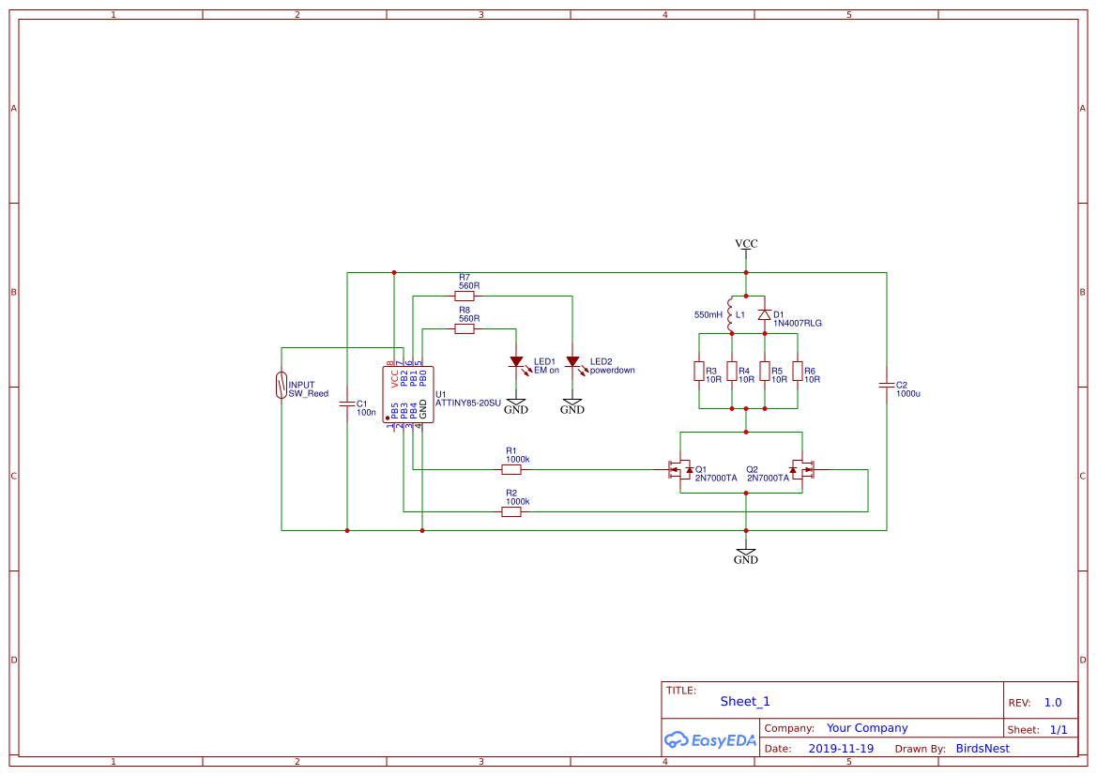

The AT Tiny 85 microcontroller (MC) is low cost and low power. Its 8 pin DIP package is suitable for stripboard prototyping.

A Li ion battery provides high capacity (5000mAh) and moderately high voltage (3.6V).

An internal pull-up resistor of approximately 30kOhm is enabled by the software and couples the input pin PB2 to Vcc. Closure of the reed switch couples the input pin to ground.

The output circuit is a relay driver in which two n-channel MOSFET transistors switch the coil to ground when their gates are switched high by ports PB3 and PB4.

For selection of the output transistor we require: a low value for resistance RDS, Ichannel max >~ 250 mA and Vthreshold << Vcc; the 2N700 has parameters: 6 Ohm, 500 mA (pulsed) and 0.8 V respectively. To increase the current that can be sourced I use two transistors in parallel. The ON semiconductor datasheet for 2N7000 (<https://www.onsemi.com/pub/Collateral/NDS7002A-D.PDF>) reports a maximum drain current of 500mA which in this circuit limits the coil current to less than 1A.

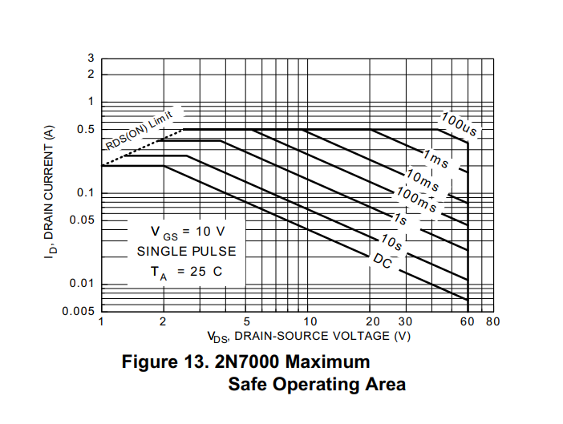

The duration of pulse to the electromagnet is defined by the software and should be set to the minimum required to activate the bike reed switch. A 20ms duration was sufficient and could potentially be reduced further. It corresponds to a maximum duty factor of ~0.06, assuming a speed of 24km/h.

The 4 parallel load resistors (R3 to R6) the resistance of the coil and the drain-source resistance of the transistors determine the steady state current, which was measured at 0.55A using a scope.

Power dissipation in the resistors is $I×R$ or 1.5W per resistor (peak); 1.5/16W (average). The resistor rating is 0.25W.

The average current drain during operation is 33mA, calculated from the duty factor and steady state on current. It indicates that 150h of operation is possible, given a 5000mAh battery capacity and a 3Hz maximum output pulse frequency.

# Design of electromagnet and geometry of mounting

The coil field is given by

$B_{max}= \text{μ }μ_{0}\text{ η Ι}$,

where $\text{η}$ is the number of turns per unit length(m) and $\text{μ}$ is the relative permeability of the core, $μ_{softiron}$ ~ 1000

300 turns in 30mm gives $B_{max}=$ 7T (in the centre of the core). The field in the centre of the solenoid is concentrated and relatively uniform; the field outside weak (orders of magnitude smaller) and divergent.

A coil located around the bike reed switch would provide the most efficient way to couple to the switch. In fact manufacturers specify reed switch sensitivity as the number of amp turns needed for such a coil to close the switch (5-10AT is typical). Unfortunately, to install such a coil would require the cable for the bike sensor to be disconnected and the deregulator to be passed along the cable starting at the end with the connector.

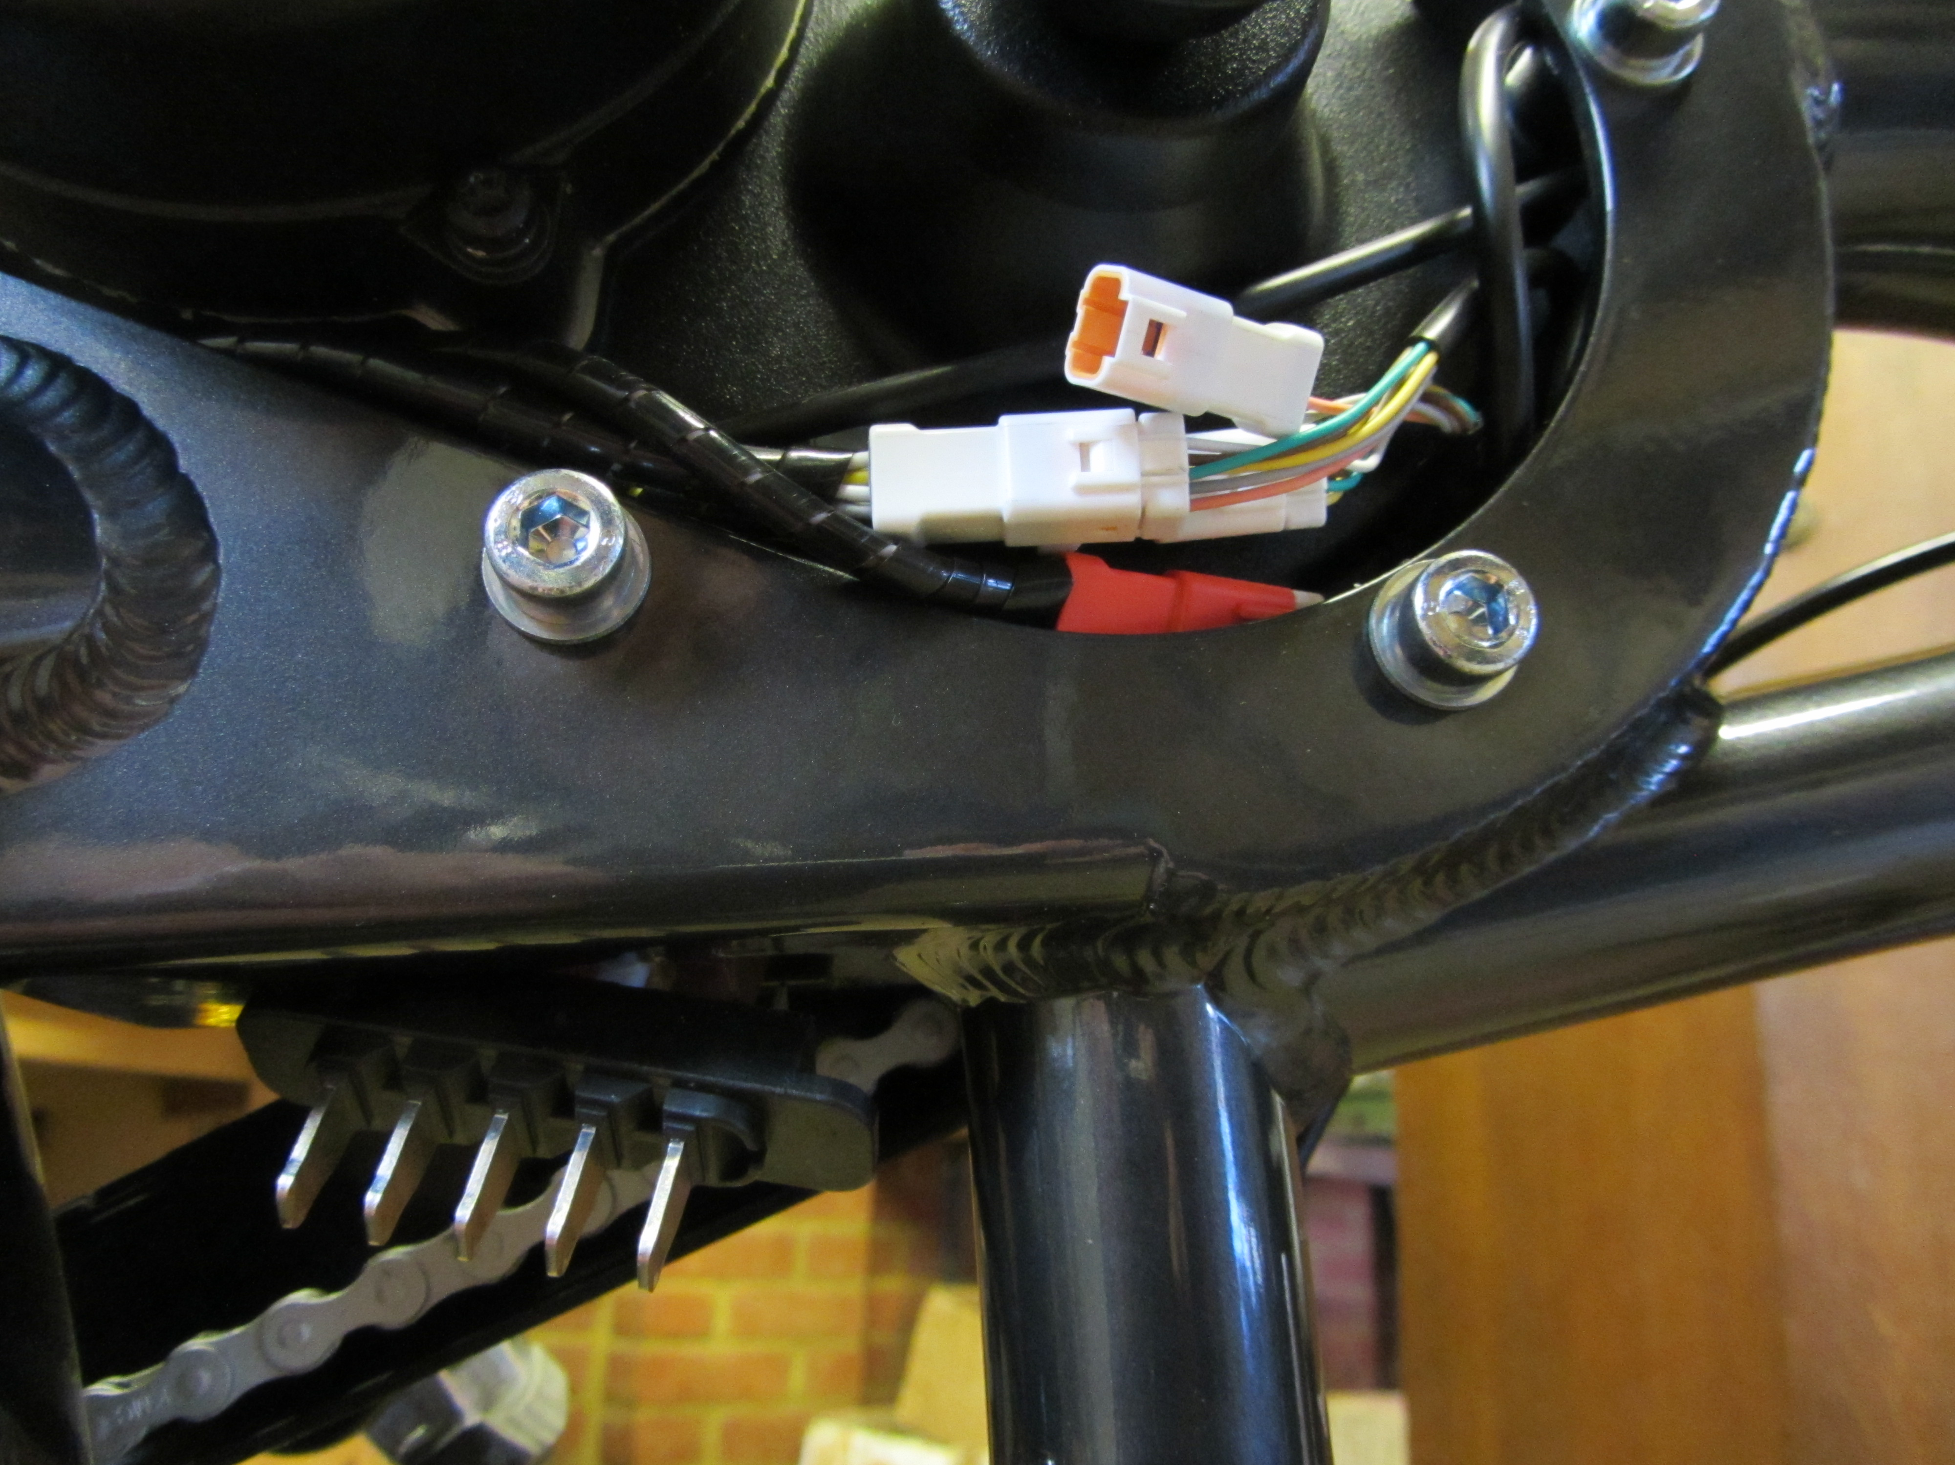

Instead to facilitate installation, I locate the coil adjacent and parallel to the bike reed switch. This requires a larger number of current turns.

I did not explore the possibility of mounting the coil with its axis perpendicular to the axis of the reed switch.

# Software design

The MC firmware is in this repository <https://github.com/RobWilks/Pedelec>

Pin2/INT0 is used as the reed switch input since it can provide an external interrupt to wake-up the MC from powerdown – with the AT Tiny85 only logic level 0 will interrupt a power down; level change and rising/falling edges do not appear to work.

There are four output ports: 2 to drive LEDs and 2 to drive the gates of MOSFETs. The MOSFETs and first LED are switched simultaneously by writing to PORTB register.

The mapping between input and output is piecewise linear. The output pulse period $t_{out}$ is equal to the input period for speeds less than 10km/h; for higher speeds $t_{out}$ is given by:

$$t_{out}=t_{10}{-κ\left(t_{10} - t_{in}\right)}_{}$$

$$κ={\left(\frac{t_{24} - t_{10}}{t_{64} - t_{10}}\right)}_{}$$

$$κ=\frac{56}{81}$$

where $t_{n}$ is the time for one wheel revolution at *n* km/h. The minimum floor for $t_{out}$ is set at $t_{24}$.

To increase battery life, the MC powers down if there no input pulses are detected over a period timeSleep; in powerdown quiescent current is less than 10µA.

The first LED indicates current flow to the electromagnet; the second LED indicates when the MC enters and exits powerdown.

Positioning the bike reed switch is facilitated by a test signal, wherein the electromagnet is pulsed at 1s intervals. The test routine is initialised by fixing a small permanent magnet close to the input reed switch, e.g. using adhesive putty or tape. The test routine starts once the reed switch has remained closed for at least 30s after exit of powerdown; it ends once the reed switch opens. To avoid inadvertent battery drain, the routine sleeps after 60 pulses (1 minute).

# Mechanical design

The battery, stripboard, electromagnet and bike reed switch were housed in an ABS box of dimensions (80mm x 40mm x 25mm). The input reed switch was mounted outside the box to bring the switch closer to the wheel (see photo).

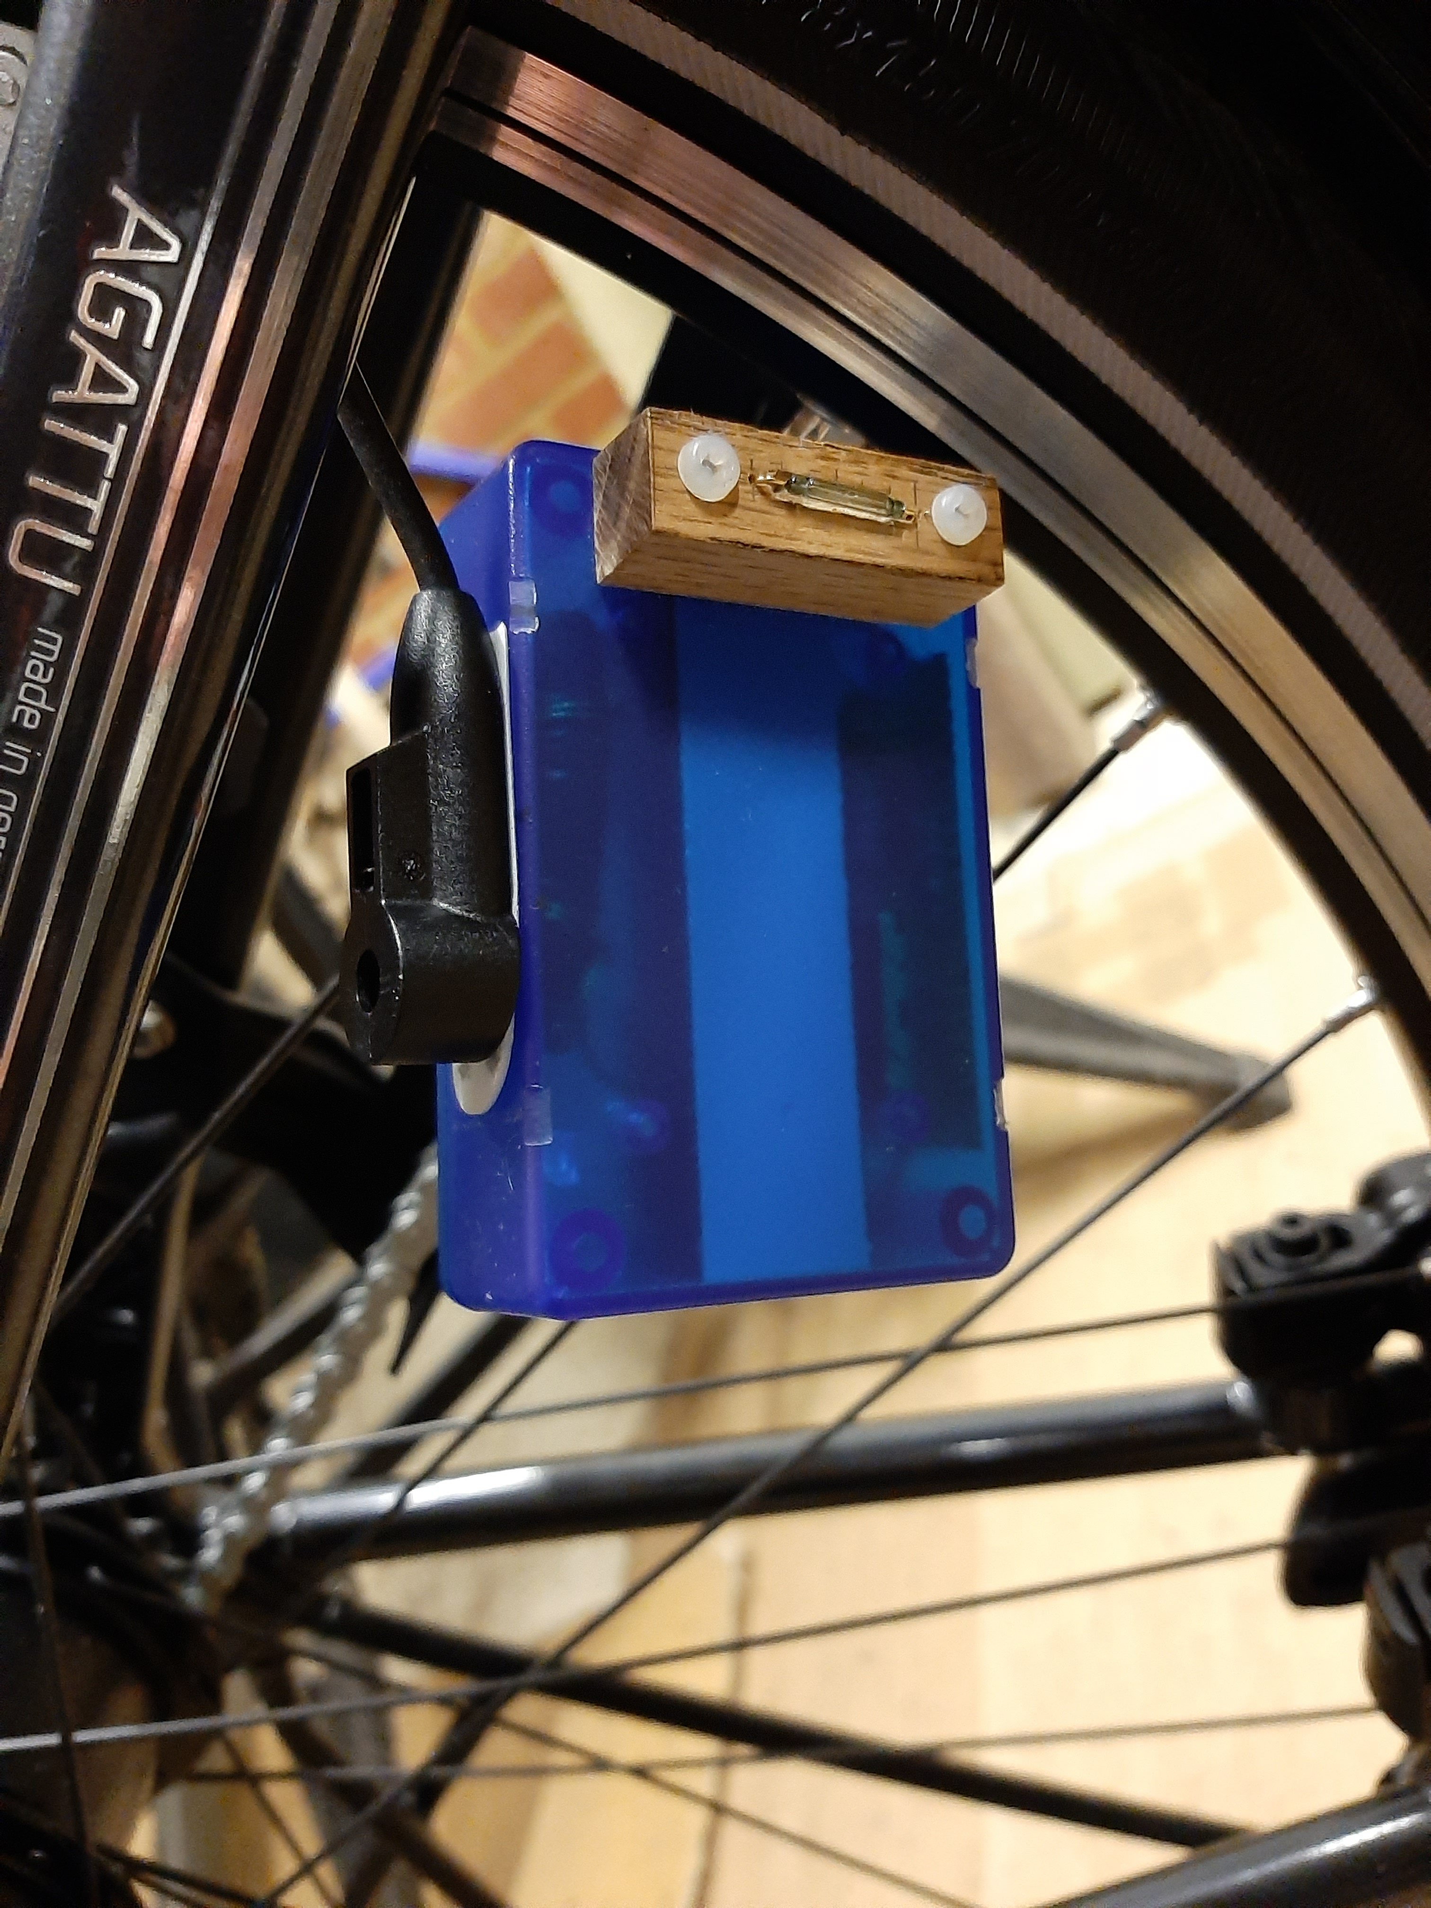

In the first arrangement, shown in the photo above, the bike reed switch was mounted with Command adhesive on the outside of the case. Unfortunately, the field from the electromagnet would not close the switch at this distance (3 - 5mm); the bike reed switch was relocated inside the box within 1-2mm of the electromagnet.

The bike sensor cable enters the box via a round hole formed between the top of the wall of the box and the lid. Closure of the lid clamps the cable insulation, allowing a waterproof seal to be created. The box was mounted to the underside of the rear stay using a combination of Command adhesive and cable ties.

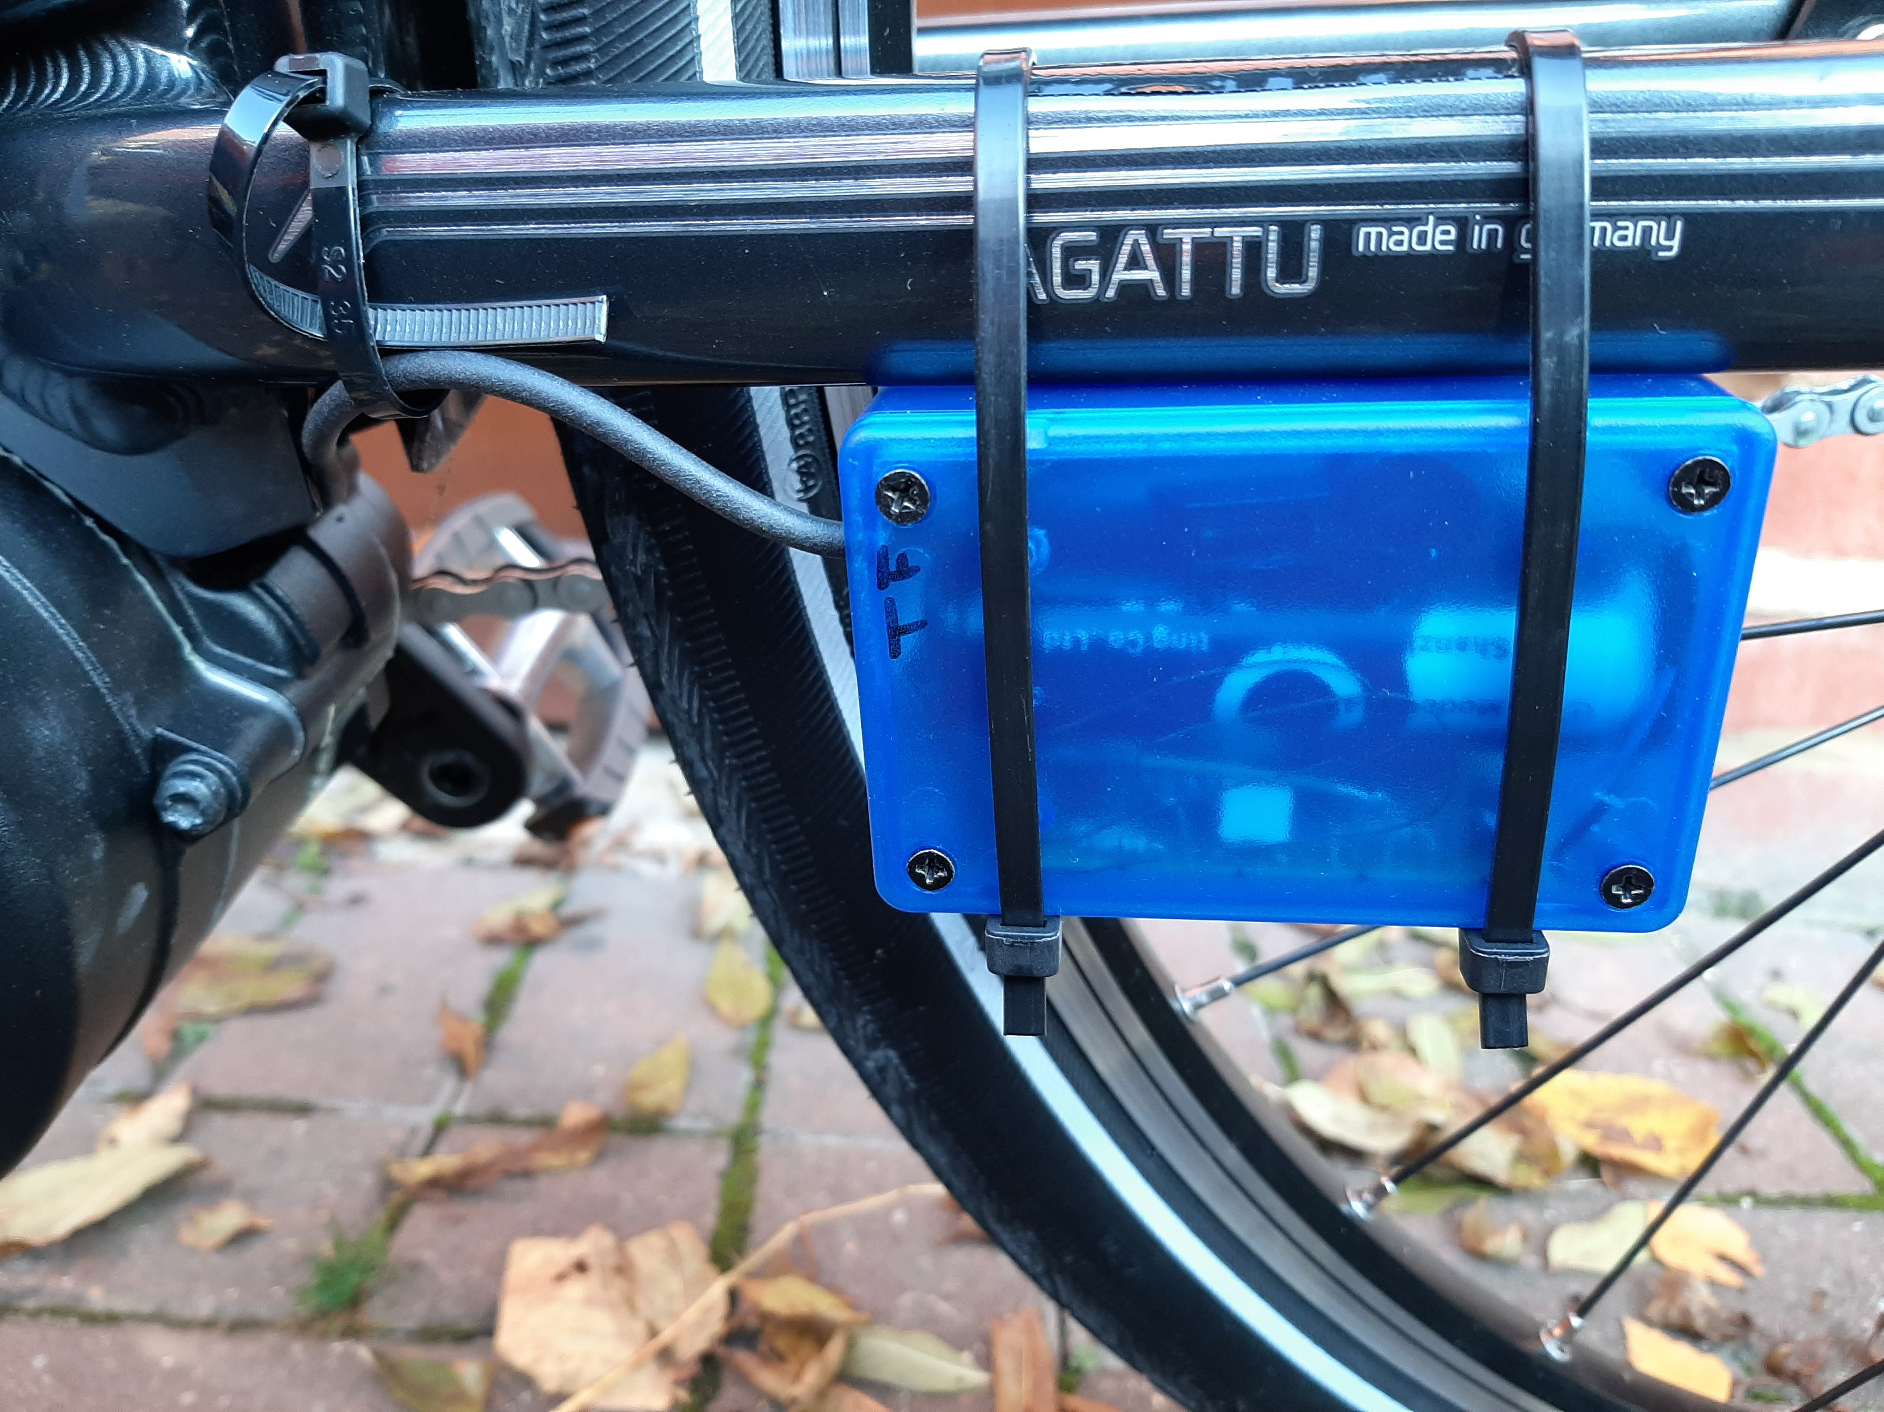

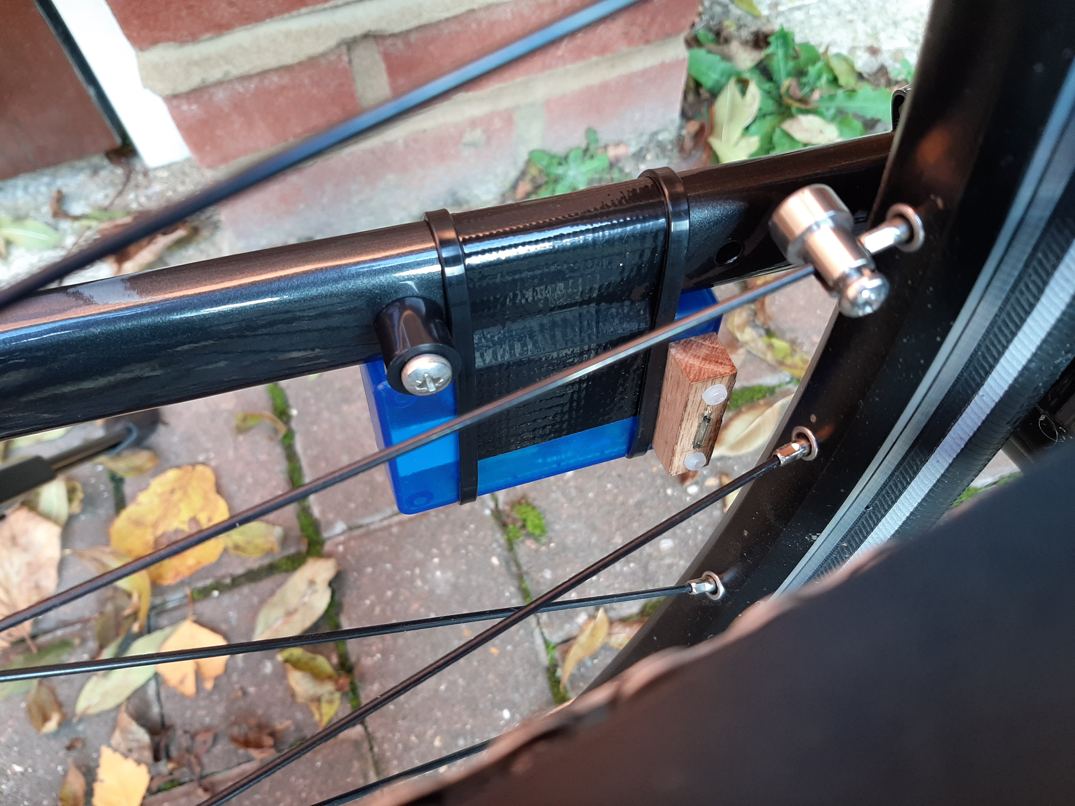

# Development issues

* Low sensitivity of bike reed switch
* Sourcing an electromagnet with appropriate field strength and geometry
* Testing whether the bike reed switch had activated without needing to ride the bike
* Optimum electromagnet/switch geometry
* Switch debounce
* Double pulse on reed switch
* Datasheet description of sleep modes of AT Tiny with external interrupt are subtle/confusing

# Testing

The hardware and software worked as expected. However, the high rolling resistance, air resistance and mass of the bike result in a low top speed at full motor power (250 W). The graph below shows a speed and elevation plot for a test ride in moderately rolling country on a relatively smooth tarmac surface. The average speed is 35 km/h and the top speed 43 km/h. The range on a fully charged battery (nominally 620 Wh) was approximately 60 km; less than expected from the power rating of the motor.

